Question 1

$A={15.25}_{10}$ in binary ${1111.01}_{2}=1.11101*2^{3}$
$S_{A}=0 +v_{e}$ , $e_{A}=bias+3=01111111+00000011=10000010$
$$m_{A}=11101000→0$$

Representation of A
23 bits

A= | 0 | 10000010 | 111010…0

$B={-0.25}_{10}$ in binary ${-0.01}_{2}=-1.0*2^{-2}$
$S_{B}=1 -v_{e}$ , $e_{B}=-2+127=01111111+11111110=01111101$
$$m_{B}=0000→0$$

Representation of B
23 bits

B= | 0 | $$01111101$$ | 000000…0

Comparison of exponents: $e_{A}>e_{B}$
Difference of exponents:$e_{A}-e_{B}=10000010-01111101=00000101$

$=10000010+00000011 =00000101$

shift smaller operand by $00000101=5_{10}$ to the right

$$m_{B}=1.00000→*2^{-5}=0.0001$$
$${-m}_{B}=1.1110+1=1.1111$$

Now A

$$m_{A}+m_{B}=1.11101+\left(-0.00001\right)=001.11101+111.1111=01.11100$$
$$m_{result}=01.111000…0*2^{3}$$

Normalization$→$ not required Subtraction
Rounding $→$ not required $R\left(M_{0}+S\right)=0$

$∴e_{R}=e_{A}=10000010$
0 | 10000010 | 11100000…0
$m_{R}=111000→0$
$$S=0 (+ve)$$
23 bits

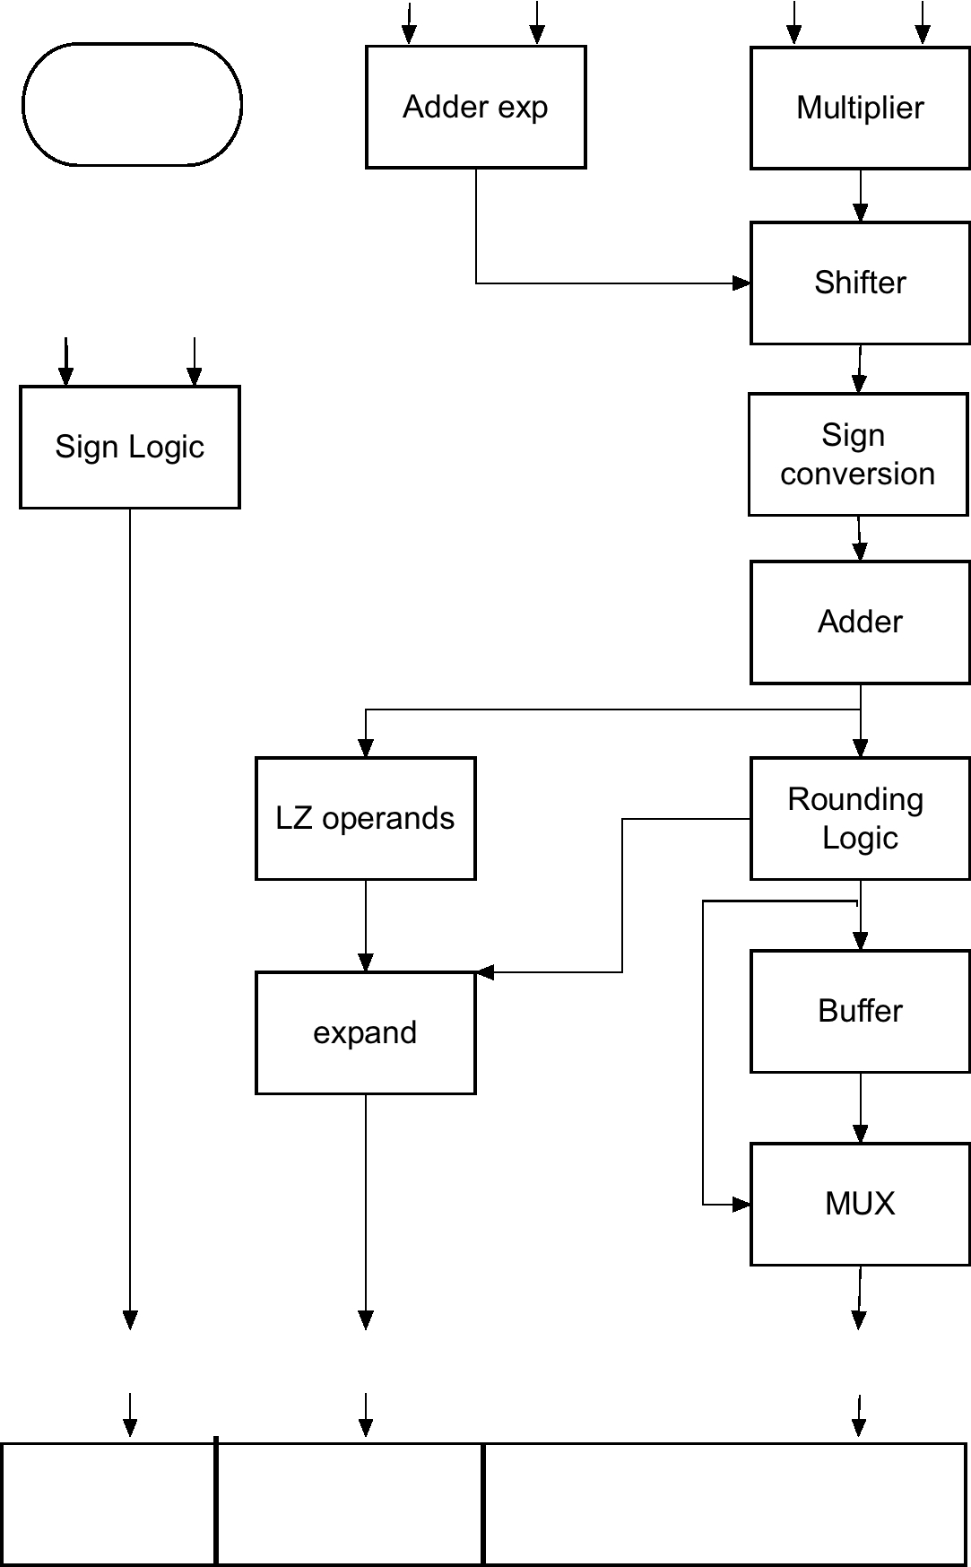
$$m_{B}$$
$$m_{A}$$
$$e_{B}$$
$$e_{A}$$
$$S_{A}$$
$$S_{B}$$
$$m_{R}$$
$$e_{R}$$
$$S_{R}$$

Question 2

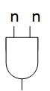
Use to produce partial products

 |  |  |  | $$X_{3}$$ | $$X_{2}$$ | $$X_{1}$$ | $$X_{0}$$
 |  |  |  | $$X_{3}$$ | $$X_{2}$$ | $$X_{1}$$ | $$X_{0}$$
 |  |  |  | $$X_{0}X_{3}$$ | $$X_{0}X_{2}$$ | $$X_{0}X_{1}$$ | $$X_{0}X_{0}$$
 |  |  | $$X_{1}X_{3}$$ | $$X_{1}X_{2}$$ | $$X_{1}X_{1}$$ | $$X_{1}X_{0}$$
 |  | $$X_{2}X_{3}$$ | $$X_{2}X_{2}$$ | $$X_{2}X_{1}$$ | $$X_{2}X_{0}$$
 | $$X_{3}X_{3}$$ | $$X_{3}X_{2}$$ | $$X_{3}X_{1}$$ | $$X_{3}X_{0}$$
 | $$X_{3}X_{2}$$ | $$X_{1}X_{3}$$ | $$X_{0}X_{3}$$ | $$X_{0}X_{2}$$ | $$X_{1}X_{0}$$ | 0 | $$X_{0}$$
 | $$X_{3}$$ |  | $$X_{2}X_{1}$$ |  | $$X_{1}$$
 |  |  | $$X_{2}$$

$$0$$
$$X_{1}X_{3}$$
$$X_{2}X_{1}$$
$$X_{2}$$
$$0$$
$$X_{1}X_{0}$$
$$X_{0}X_{2}$$
$$X_{1}$$
$$0$$
$$X_{0}$$

$$0$$
$$X_{0}X_{3}$$
$$0$$
$$X_{3}X_{2}$$
$$0$$

$$0$$
$$X_{3}$$
$$P_{7}$$

$$P_{6}$$

$$P_{5}$$

$$P_{4}$$

$$P_{3}$$

$$P_{2}$$

$$P_{1}$$

$$P_{0}$$

$$Delay=8FA+1 AND$$

if X is a 2’s complement number, than we have to convert the number as follows:

$$X_{2}$$
$$X_{1}$$
$$X_{0}$$
$$X_{3}$$

0

0
0
$$N_{3}$$

 |  | $$N_{2}$$ | $$N_{1}$$ | $$N_{0}$$
 |  | $$N_{2}$$ | $$N_{1}$$ | $$N_{0}$$
 |  | $$N_{0}N_{2}$$ | $$N_{0}N_{1}$$ | $$N_{0}N_{0}$$
 | $$N_{1}N_{2}$$ | $$N_{1}N_{1}$$ | $$N_{1}N_{0}$$
$$N_{2}N_{2}$$ | $$N_{2}N_{1}$$ | $$N_{2}N_{0}$$
$$N_{1}N_{2}$$ | $$N_{2}N_{1}$$ | $$N_{1}N_{0}$$ | 0 | $$N_{0}$$
$$N_{2}$$ |  | $$N_{1}$$
$$N_{1}N_{0}$$
$$N_{1}$$
0
$$N_{0}$$
$$N_{2}$$
$$N_{1}N_{2}$$
0
$$N_{2}N_{1}$$

$$0$$

$$0$$

$$P_{5}$$

$$P_{3}$$

$$P_{2}$$

$$P_{0}$$

$$P_{1}$$

$$P_{4}$$

Question 3

State diagram:
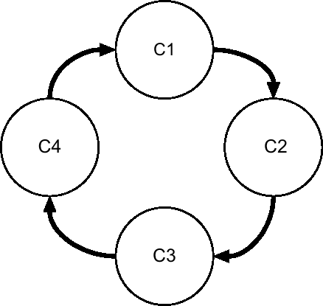

State table:
Present State | Next State
$$C_{1}$$ | $$C_{2}$$
$$C_{2}$$ | $$C_{3}$$
$$C_{3}$$ | $$C_{4}$$
$$C_{4}$$ | $$C_{1}$$

State assignment:
$C_{1}=00$, $C_{2}=01$, $C_{3}=10$, $C_{4}=11$
Excitation table:
$$y_{1}$$ | $$y_{0}$$ | $$y_{1}^{+}$$ | $$y_{0}^{+}$$
0 | 0 | 0 | 1
0 | 1 | 1 | 0
1 | 0 | 1 | 1
1 | 1 | 0 | 0

From table excitation vectors can be read directly:
$$y_{1}^{+}=y_{1}⨁y_{0}$$
$$y_{0}^{+}=\overline{y_{0}}$$

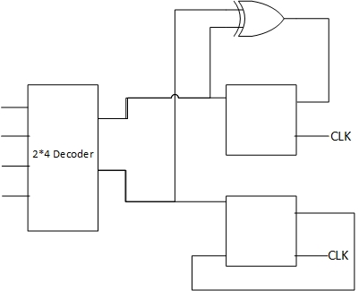
$$\overline{y_{0}}$$
$$y_{0}$$
$$C_{3}$$
$$C_{2}$$
$$C_{1}$$
$$C_{0}$$
$$y_{0}$$
$$y_{1}$$
$$y_{1}$$

